Constructing a Debounced GPIO Input Interface: Push Button Controlled LED Operation
Step 1: Create a New Project for Nucleo-H753ZI
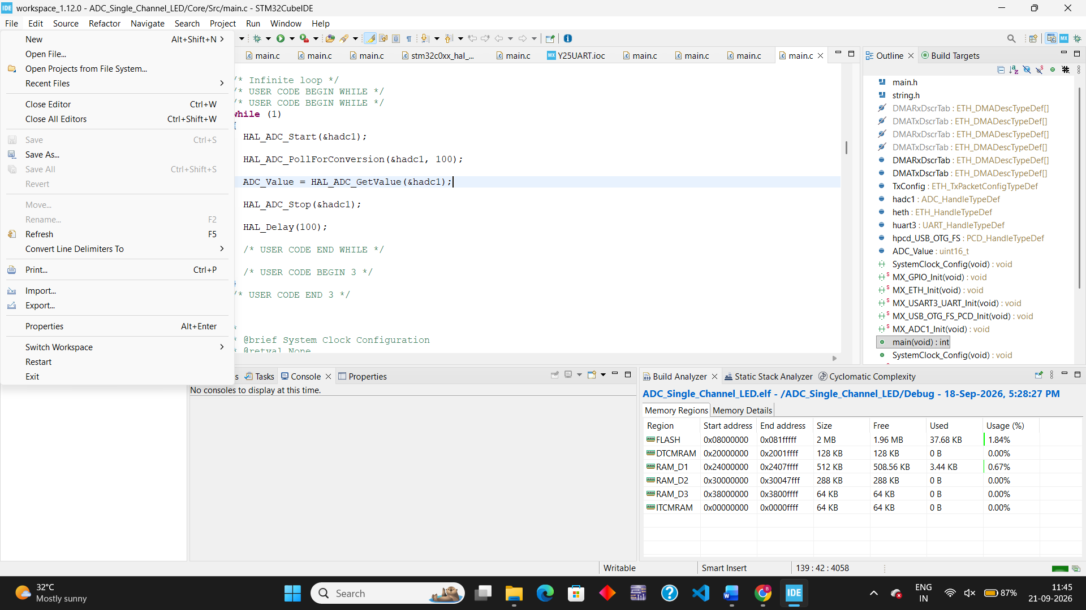
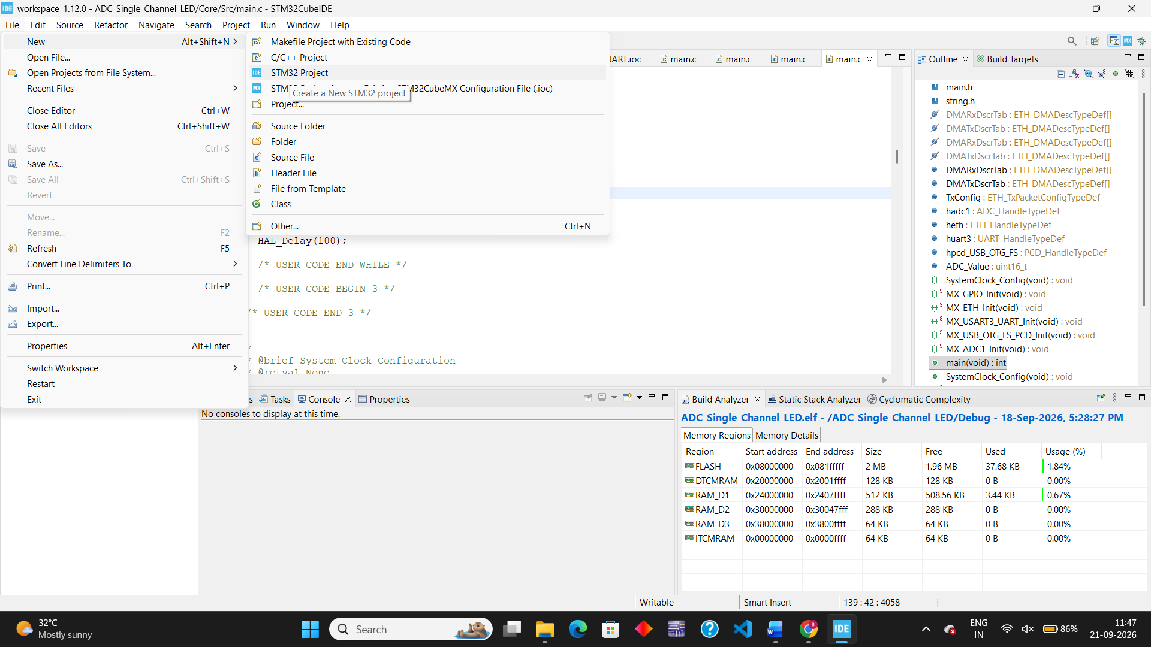
Go to filenew
New STM32 Project
Click on the STM32 Project to create a new project
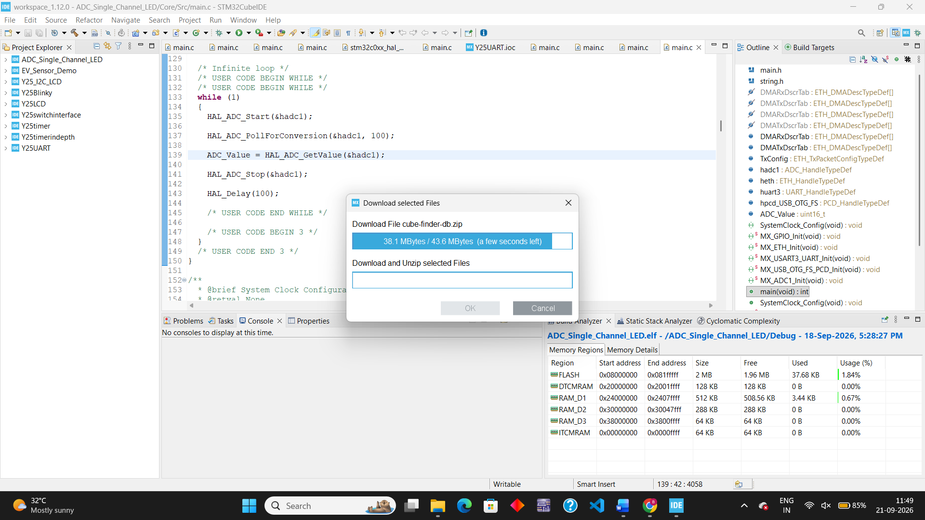
File New STM32 Project

Now here the target selector will be opened
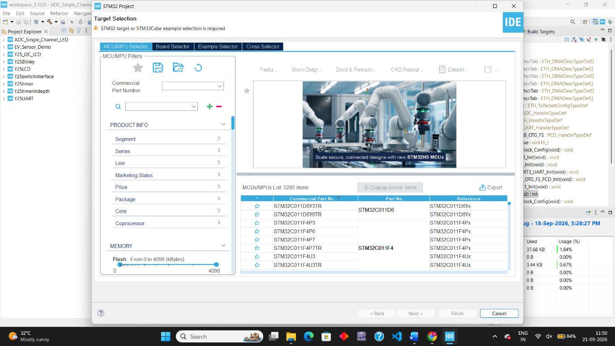
Go to click on Board Selector
Enter the board configuration for example now the present experiment is done with NUCLEO-H753ZI
Enter that in commercial Part Number
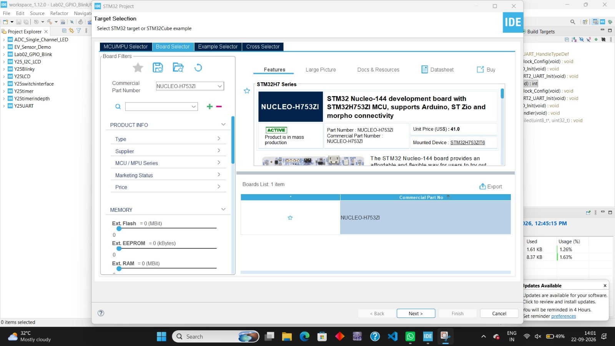
Now click on the NUCLEO board as shown and click Next
After clicking next we get a page Enter the Project Name example here I kept Lab02_H753_LED_Blink.

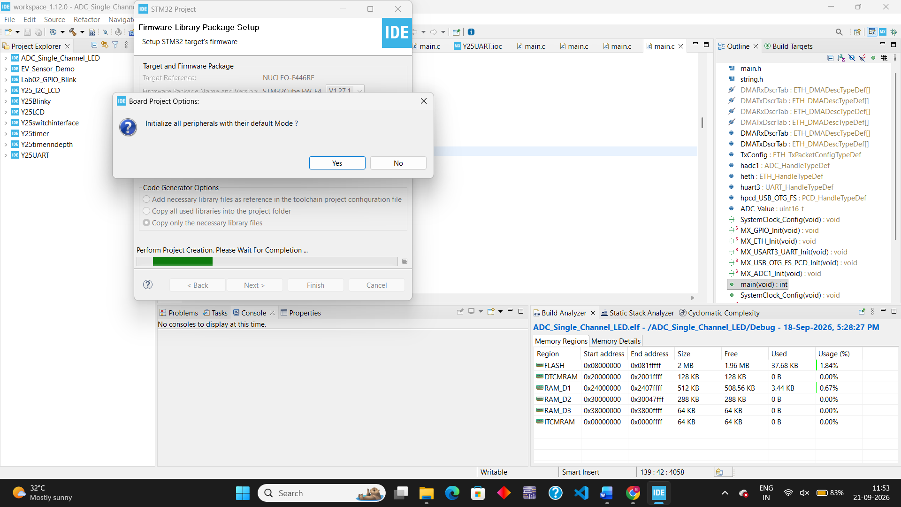
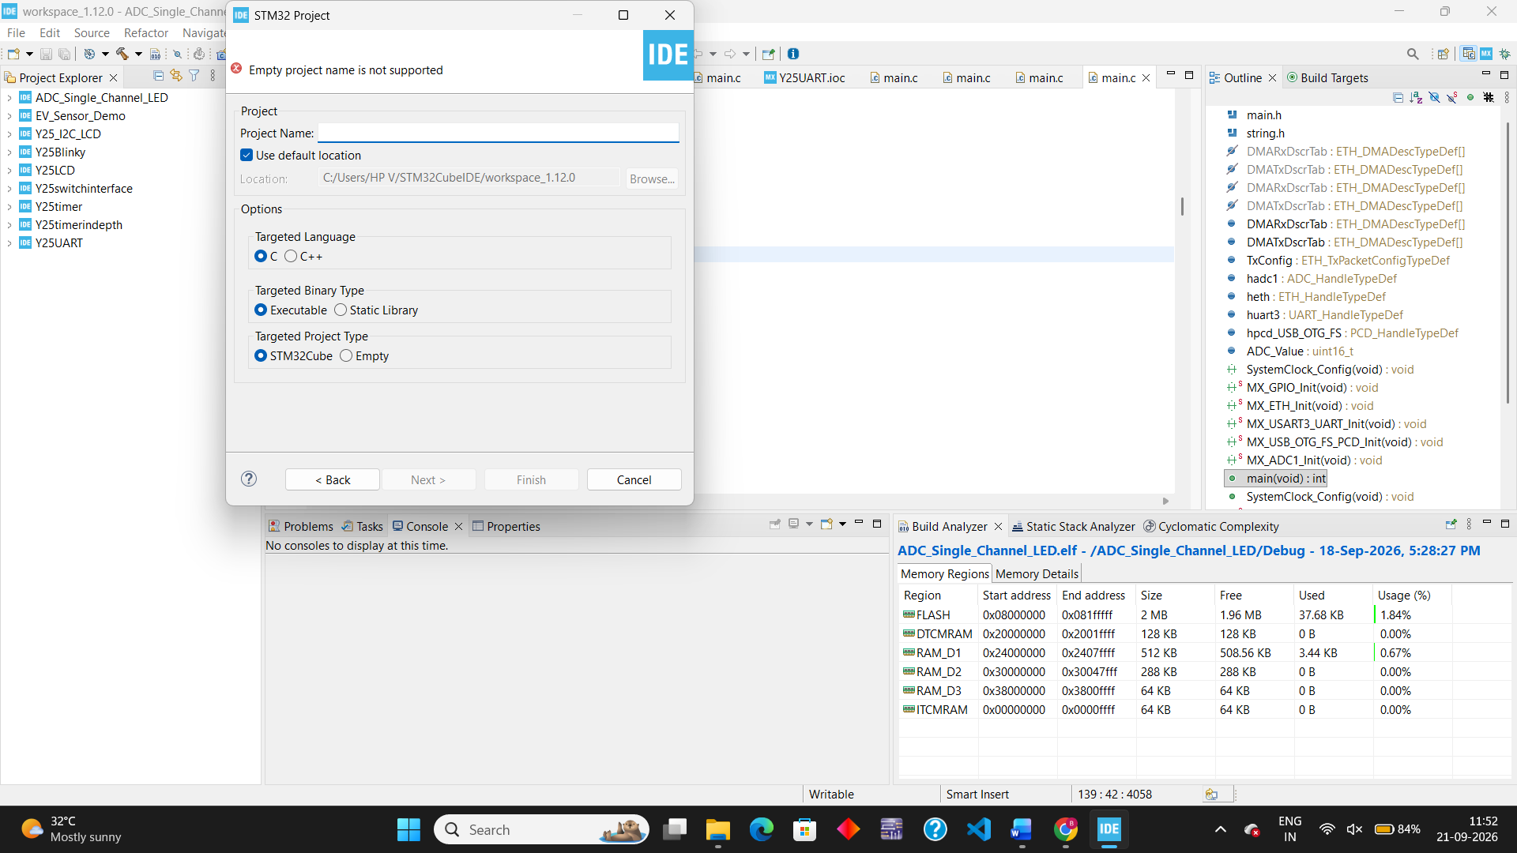
Click on next and then Finish
Click yes for the all peripheral if it appears

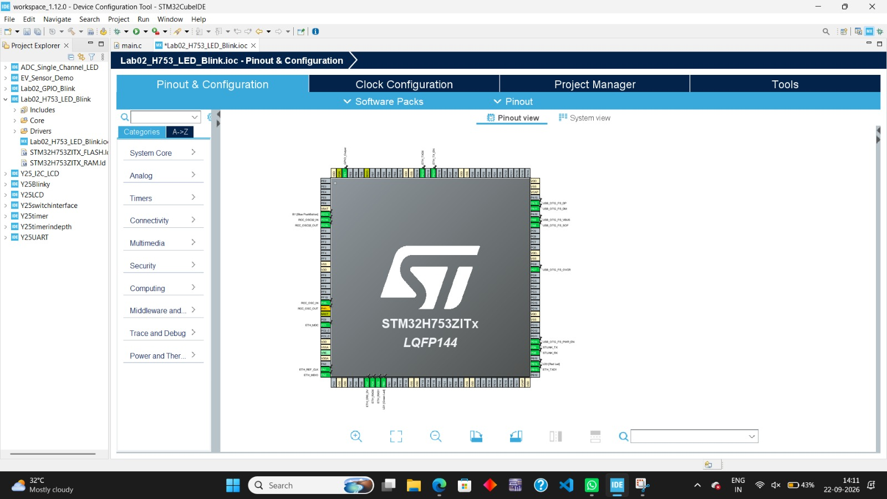
The new project is created
Now unable the required pins
In the graphical Pinout View, look for pin PE1

Click on pin PE1 and select GPIO_Output.
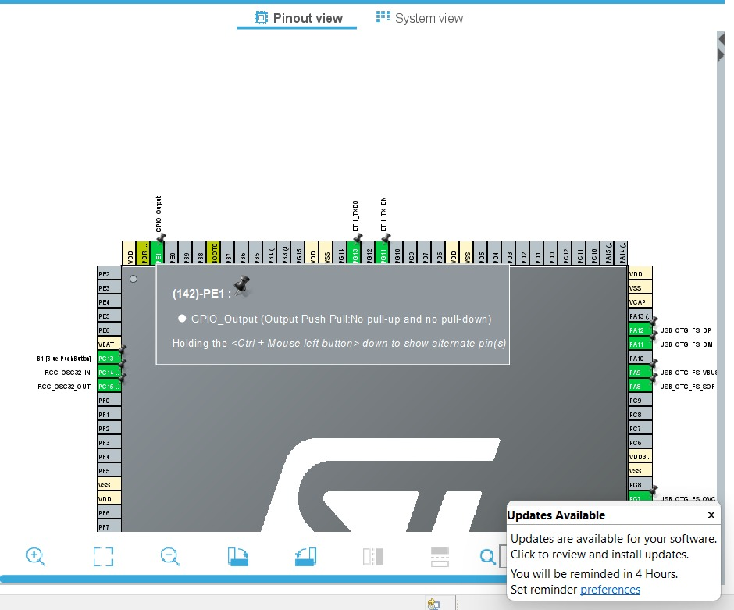
How to enable? PE1GPIO – OUTPUT
Click on the PE1 in the board and select the GPIO- OUTPUT

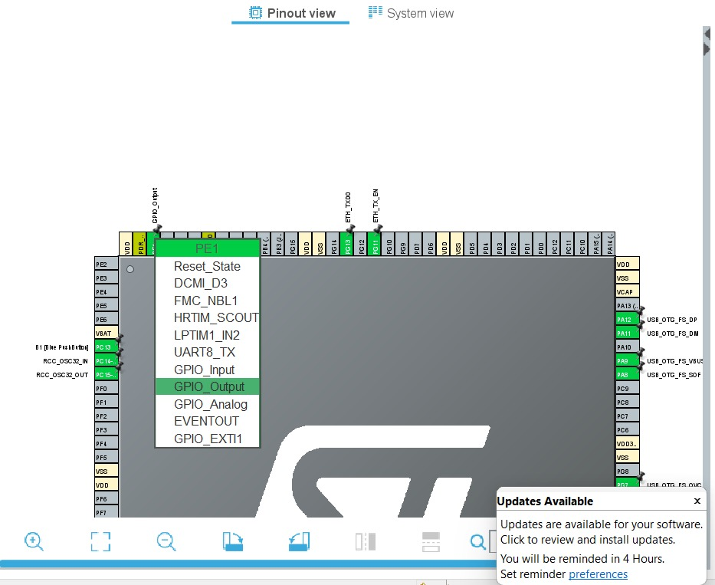
Go to the System Core menu on the left pane and click on GPIO.
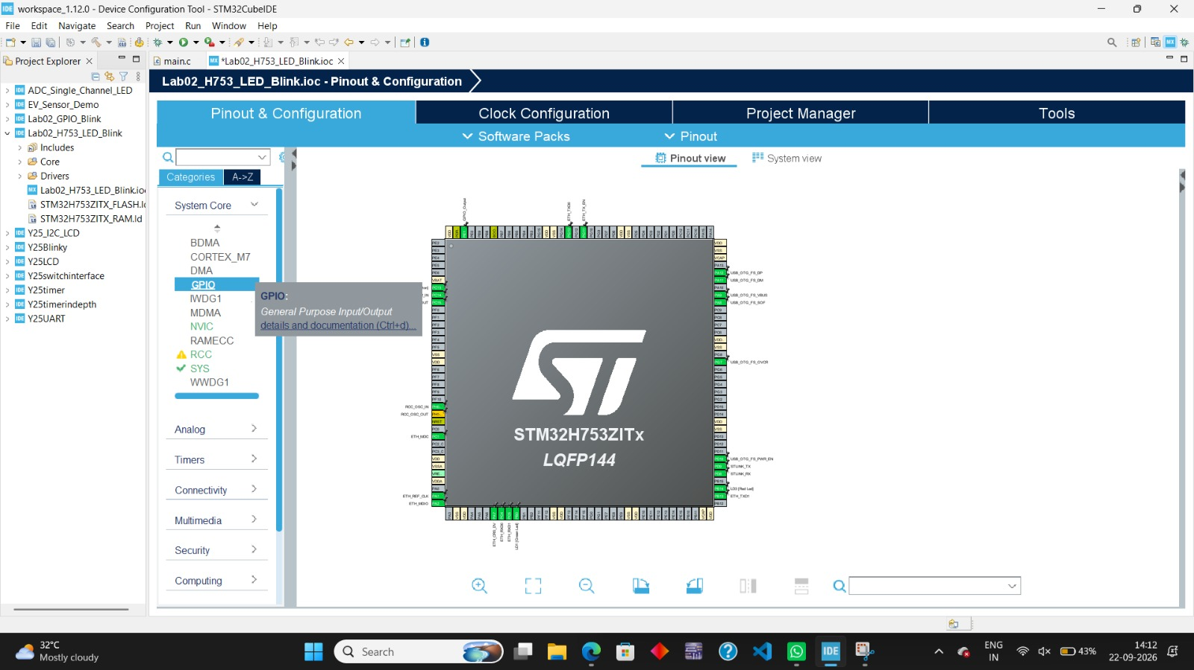
Click on PE1 in the pin list table at the bottom to view its configuration parameters.
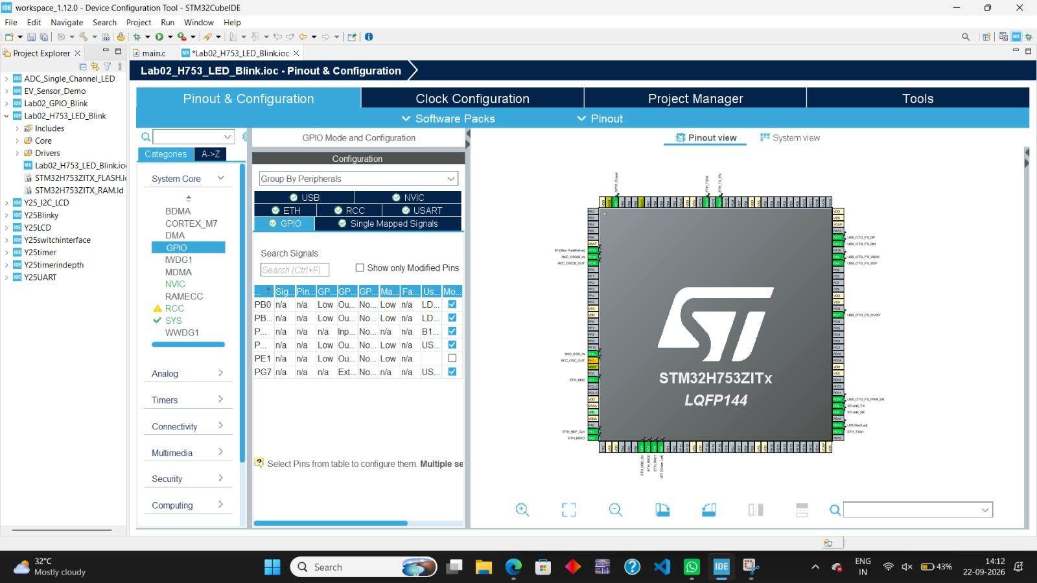

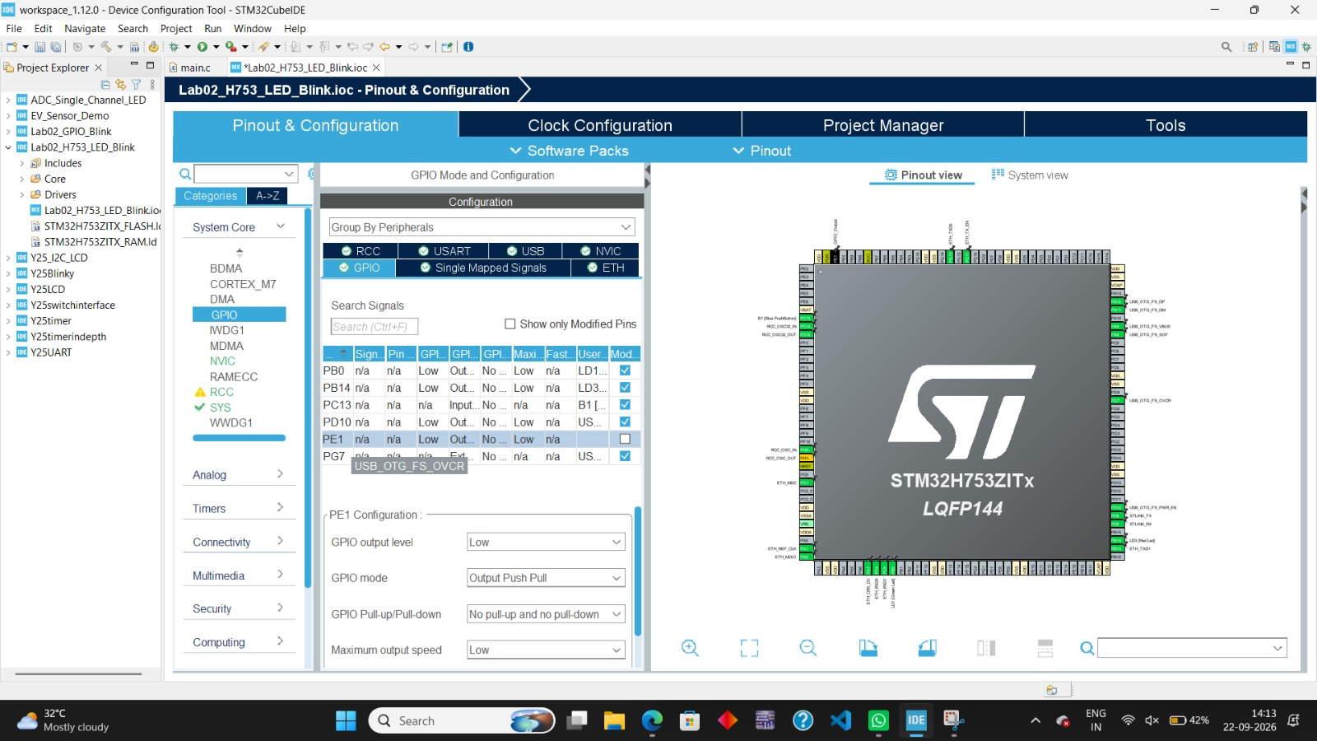
After clicking on PE1 we get the PE1 Configuration

- GPIO output level: Low
- GPIO mode: Output Push Pull
- GPIO Pull-up/Pull-down: No pull-up and no pull-down
- Maximum output speed: Low (or Medium for faster transition speeds)
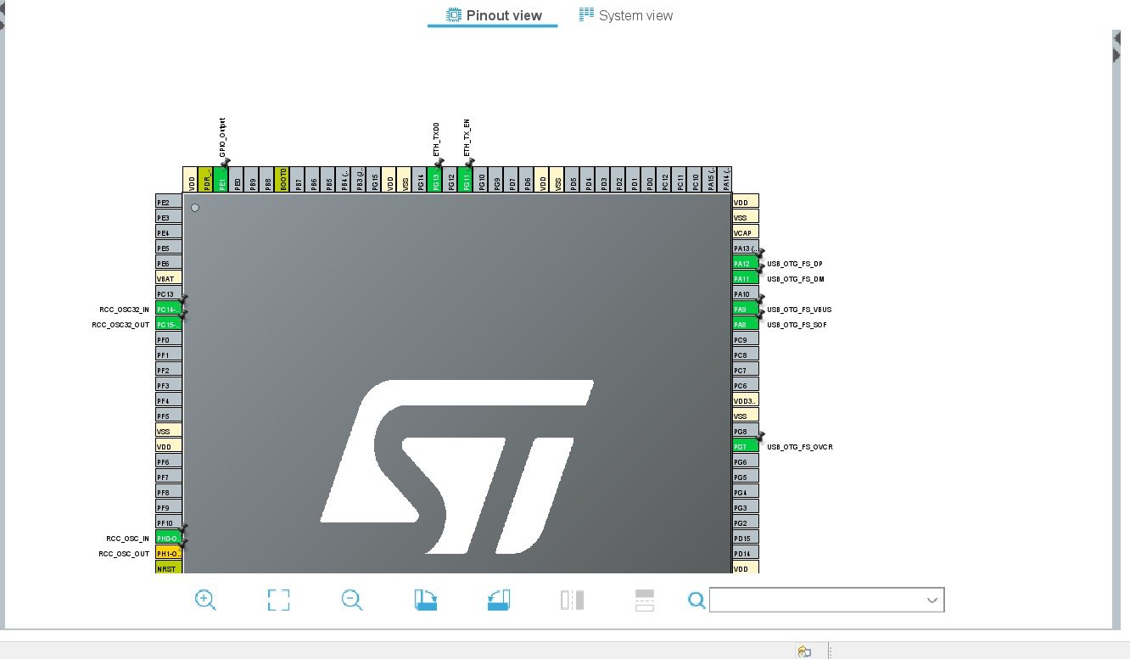

- Click on PC13 and select GPIO_Input
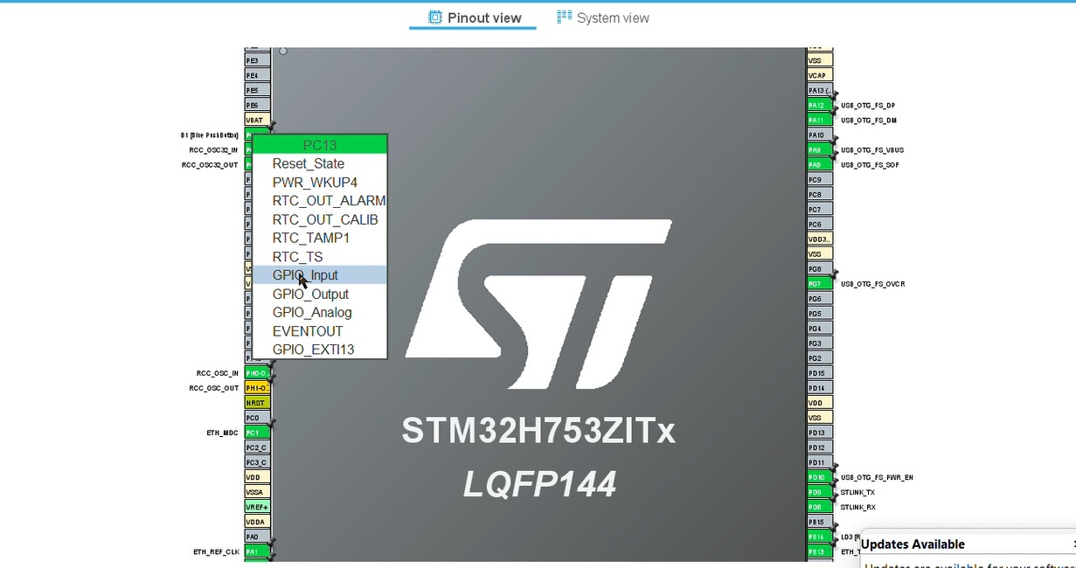

Go to the System Core menu on the left pane and click on GPIO.
After clicking on PC13 we get the PC13 Configuration
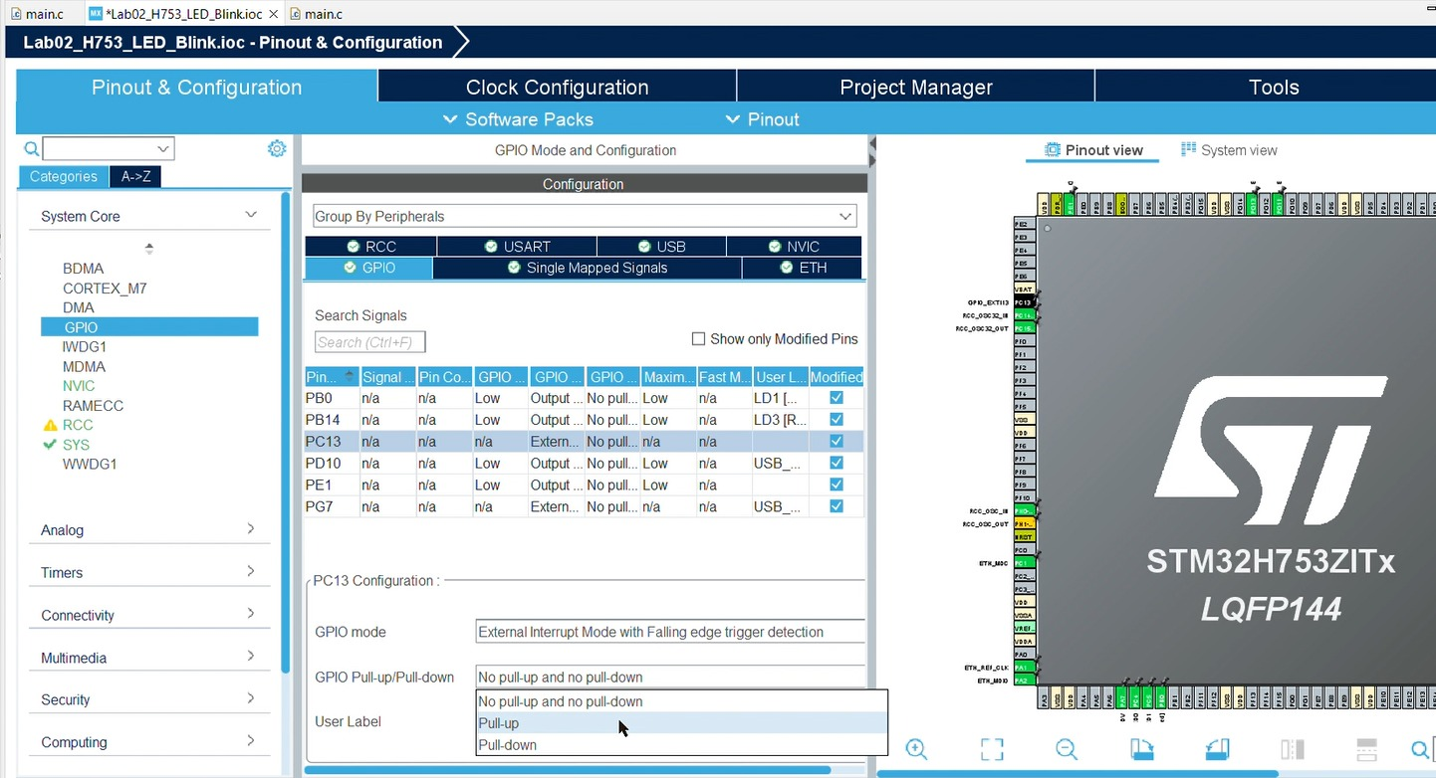
- On the left menu, go to System Core > GPIO.
- Click on PC13 in the lower configuration table:
  - Set GPIO mode to External Interrupt Mode with Falling edge trigger.
  - Set GPIO Pull-up/Pull-down to Pull-up.
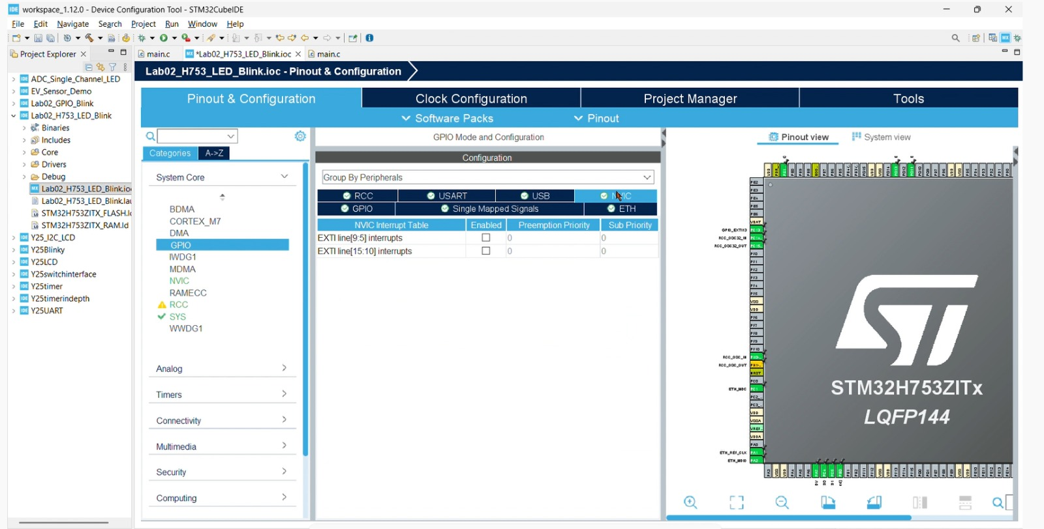

- On the left menu, go to System Core > NVIC.
- Check the box to Enable EXIT line[15:10] interrupts.
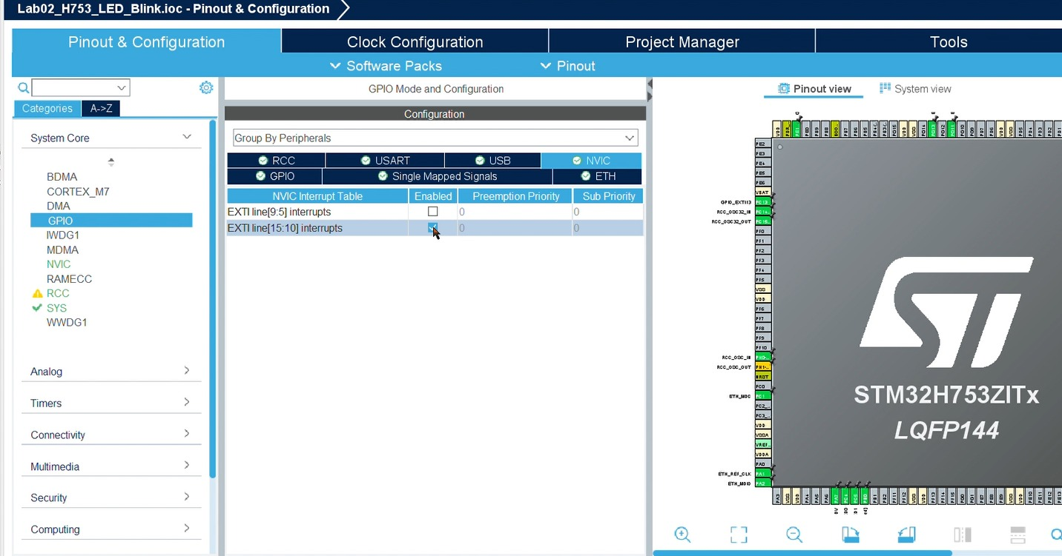

After that save(Ctrl + S) and generate code click yes
Click yes
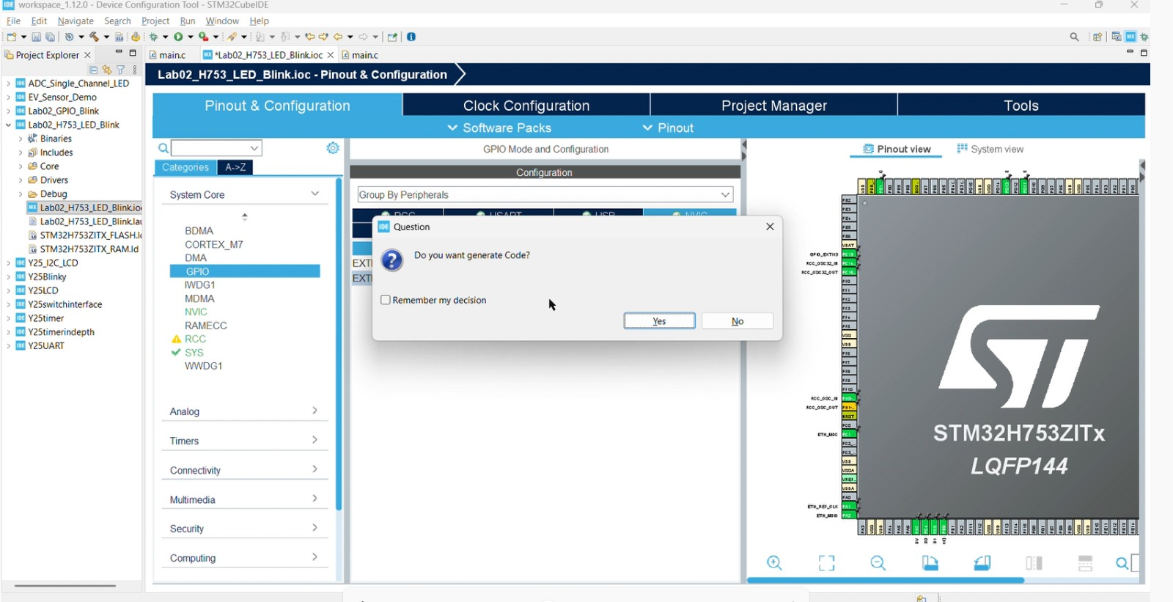
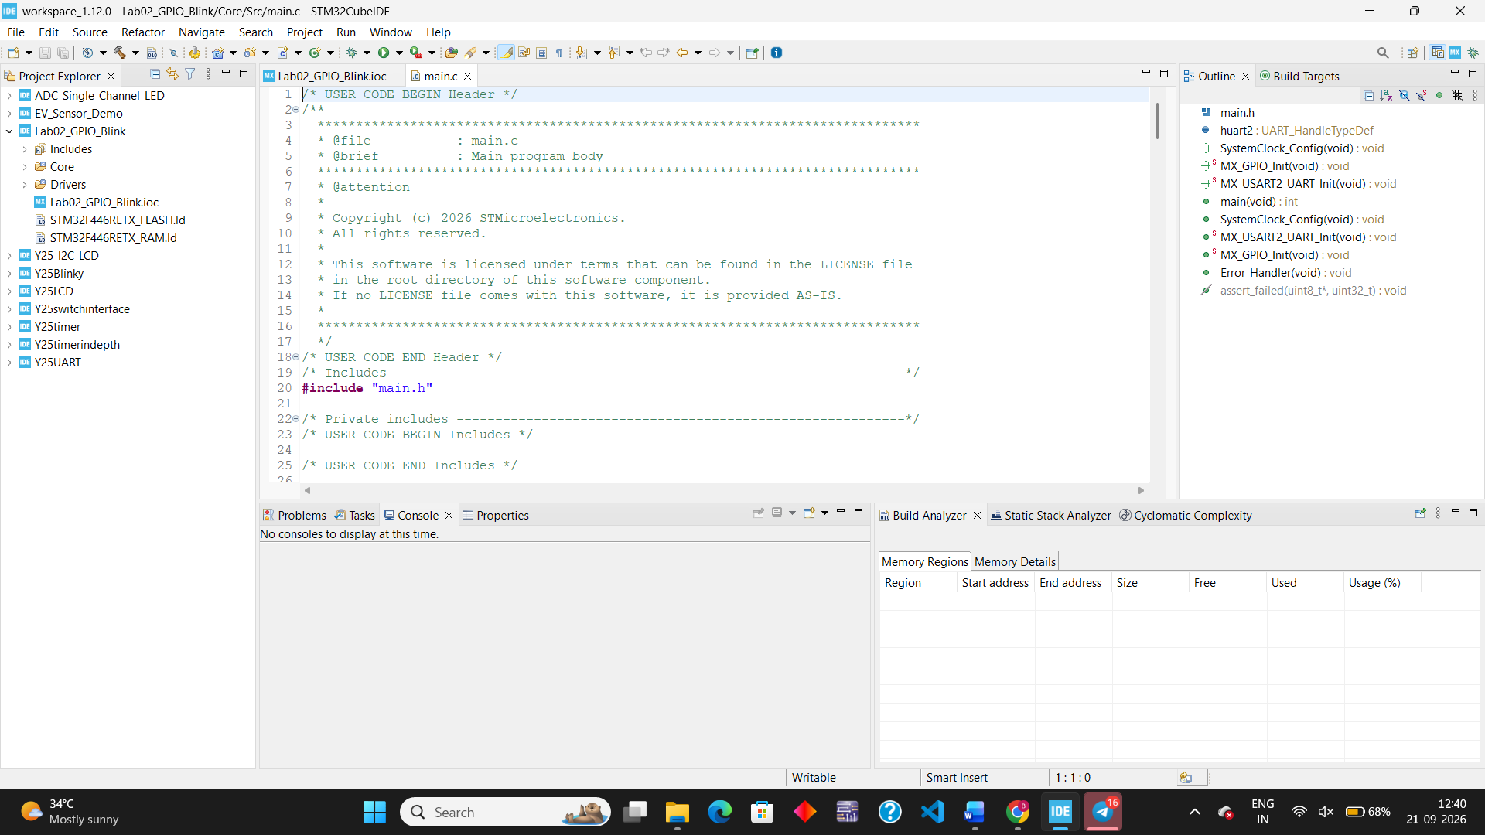
The code is generated will look like this

- Open Core > Src > main.c.
- Declare tracking variables right before the main() function or inside main() before the infinite loop:

uint32_t lastDebounceTick = 0;
uint32_t debounceDelay = 30; // 30 ms debounce filter window
GPIO_PinState lastButtonState = GPIO_PIN_SET; // Button released (active-low pull-up)

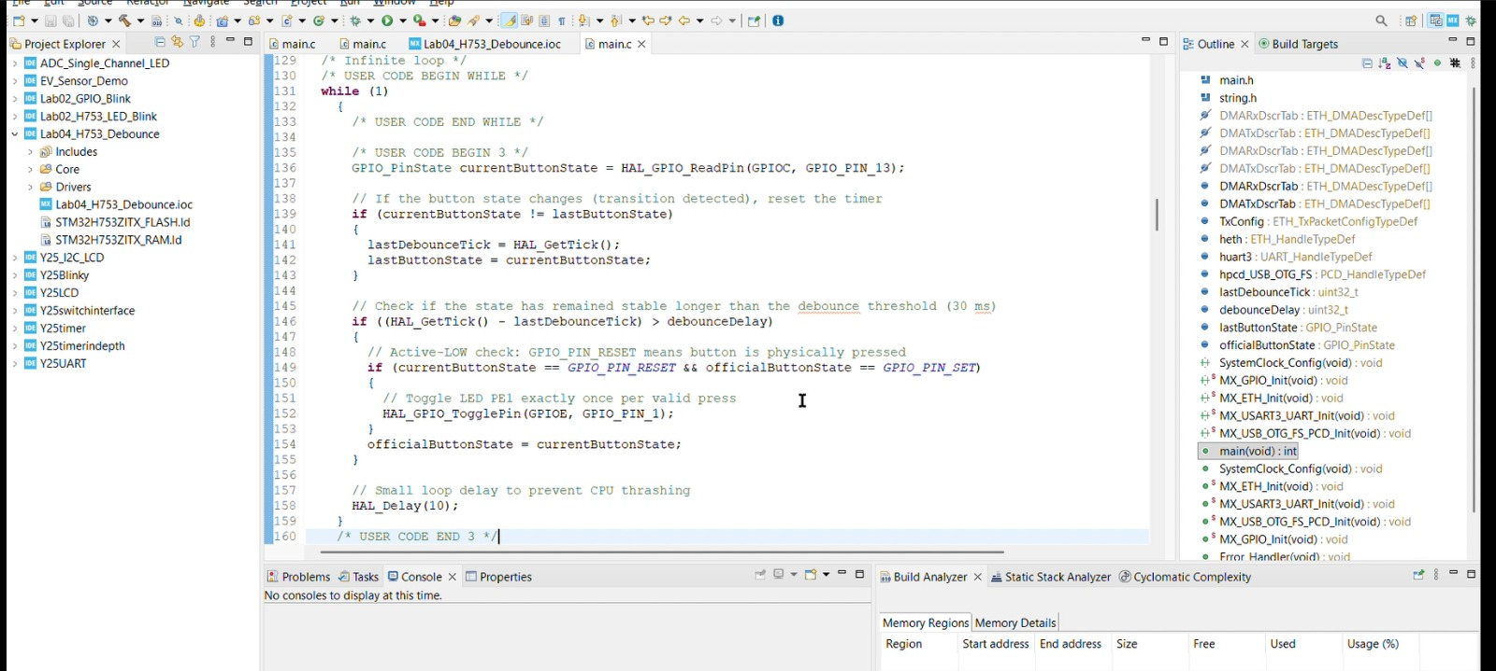
- Inside the while (1) loop of your main() function, add the polling and debounce logic:

while (1)
{
/* USER CODE END WHILE */

/* USER CODE BEGIN 3 */
GPIO_PinState currentButtonState = HAL_GPIO_ReadPin(GPIOC, GPIO_PIN_13);

// If the button state changes (transition detected), reset the timer
if (currentButtonState != lastButtonState)
{
lastDebounceTick = HAL_GetTick();
lastButtonState = currentButtonState;
}

// Check if the state has remained stable longer than the debounce threshold (30 ms)
if ((HAL_GetTick() - lastDebounceTick) > debounceDelay)
{
// Active-LOW check: GPIO_PIN_RESET means button is physically pressed
static GPIO_PinState officialButtonState = GPIO_PIN_SET;
if (currentButtonState == GPIO_PIN_RESET && officialButtonState == GPIO_PIN_SET)
{
// Toggle LED PE1 exactly once per valid press
HAL_GPIO_TogglePin(GPIOE, GPIO_PIN_1);
}
officialButtonState = currentButtonState;
}

// Small loop delay to prevent CPU thrashing
HAL_Delay(10);
}
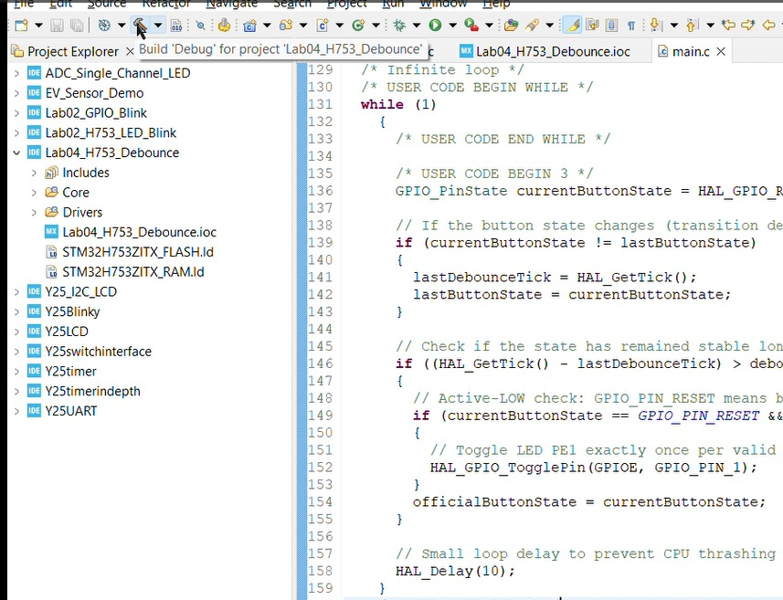

Click the Hammer (Build) icon at the top toolbar and make sure the console reports 0 Errors, 0 Warnings.
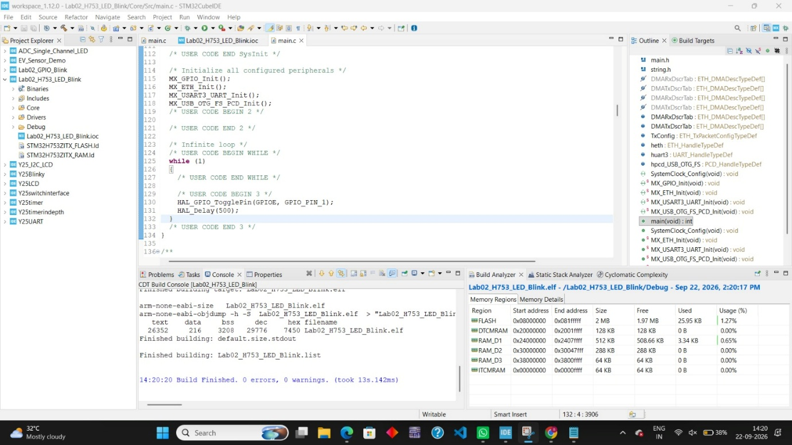

- Connect your Nucleo-H753ZI board to your laptop using the USB cable.
- Click the Run/Debug (Green Play bug icon) button to flash the code onto the board.

